

Introduction
Thank you for your interest in StarTools!
StarTools is a astronomical image post-processing program for Windows, MacOSX and Linux.
StarTools sets itself apart from other processing software by focusing on the unique needs of amateur ‘sidewalk astronomer’ in urban areas.
StarTools tries to make up for a lack of professional equipment and imaging in less-than-ideal urban skies, by leveraging the abundance of nowadays cheap CPU power and off-the-shelf imaging hardware, such as Compact Digital Cameras, Digital Single-Lens Reflex cameras and webcams. Consequently StarTools contains features and algorithms that are not commonly found in software packages for professionals, who typically have access to semi-professional equipment and dark sky sites.
StarTools can be used to post process a stacked image from start-to-finish, or may be used as part of a greater toolchain of image processing programs. Besides various unique and novel algorithms, StarTools also aims to offer equivalents of most of the various PhotoShop actions available on the web – all without the need to separately purchase a PhotoShop plug-in compatible host program.
Just a quick look at StarTools’ feature set should reveal that there is plenty on offer for both beginner and advanced imagers alike.
StarTools was created for the love astronomy and the desire to lower the barrier for beginners interested in imaging the skies. A multi-platform approach, combined with not-for-profit pricing, promotes the author’s ideal of ‘astrophotography-for-all’.

Getting Started
StarTools is very memory and CPU intensive.
A fast dual core processor with SSE3 is recommended as a minimum.
3Gb or more is recommended for 32-bit systems
6Gb or more is recommended for 64-bit systems.
Download the appropriate executable for your system and extract the ZIP file to a location of your choice.
If you purchased a license key, simply put the lice key file in the same location as the StarTools executable.
Please note that throughout this manual screenshots of the Linux version are shown, however StarTools on other platforms will appear virtually identical.

Interface
Navigation within StarTools generally takes place between the main screen and the different modules. StarTools' navigation was written to provide a fast, predictable and consistent workflow. There are no windows that overlap, obscure or clutter the screen. Where possible feedback and responsiveness should be immediate. Many modules offer on-the spot background processing, yielding quick final results for evaluation and further tweaking.
In both the main screen and the different modules, a toolbar is found at the very top, which performs functionality that is specific to the active module. In case of the main screen, this toolbar contains buttons for opening an image, saving an image, undoing the last operation, invoking the mask editor and opening an 'about' dialog.
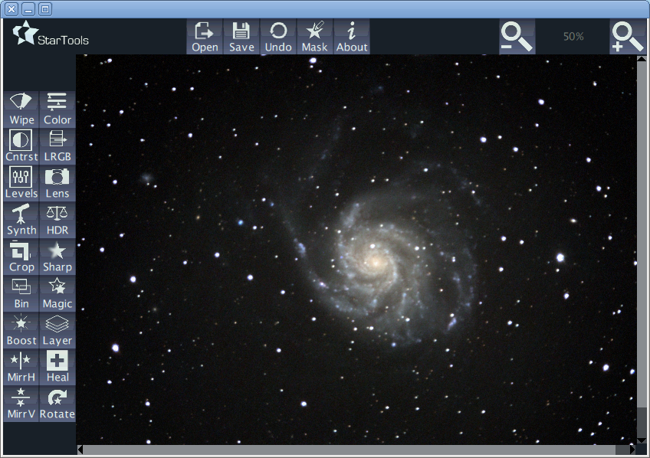Illustration 1: StarTools main screen interface
Exclusive to the main screen, the buttons that activate the different modules, reside on the left hand side of the main screen. Note that the modules will only activate once an image has been loaded.
Consistent throughout StarTools, zoom controls are found in the top right corner, along with a zoom percentage indicator.
Panning controls (scrollbar style) are found below and to the right of the image, when appropriate.
The image above shows the layout of a typical module (in this case the 'Magic' module), with the toolbar situated on top ,and the different parameters and settings, specific to the module, situated at the bottom.
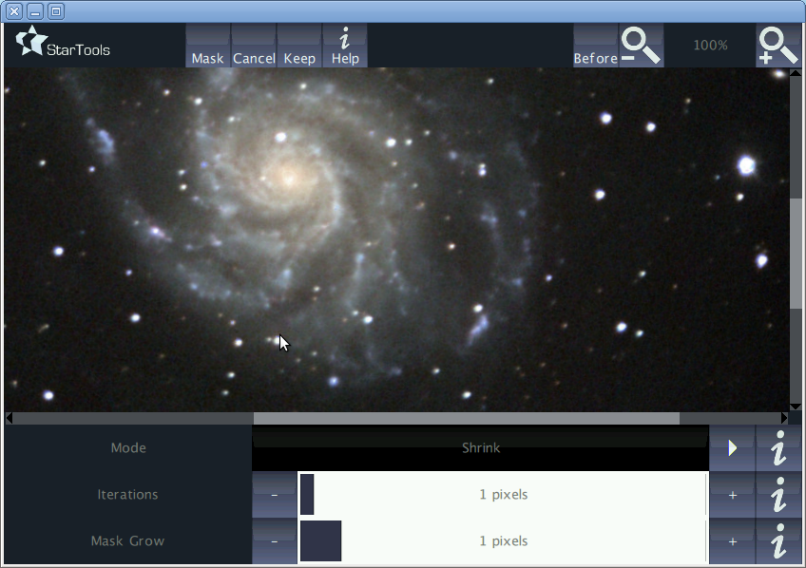Illustration 2: StarTools Magic module
Common to most modules is a 'Before/After' button, situated next to the zoom controls, which toggles between the original and processed version of an image for easy comparison.
All modules come with a 'Help' button in the toolbar, which explains in brief the purpose of the module. Furthermore, all settings and parameters come with their own individual 'Info' button, left to the parameter control. These info buttons explain in brief the nature of the parameter or setting.

Processing an image with StarTools
There are some important things you should know about the modules in StarTools.
First of all, many algorithms require a mask to operate effectively and some even will not yield any useful results without one.
Secondly, the algorithms that StarTools employ are very sensitive to excessive noise, artificial artefacts (such as stacking artefacts, borders, text, etc.) and hot and/or dead pixels.
When processing such images, be aware of their existence and try to eliminate them whenever possible before starting your processing. This may mean using the Crop tool to crop the image until stacking artefacts are no longer visible, or using the Mask and Heal modules to heal hot and dead pixels.
Some modules come with additional parameters that let you specify a noisiness level of the image so that StarTools can take precautions when processing noisy images. Failure to take noise and/or artefacts into consideration may lead to undesirable results and the introduction of artefacts or other unexpected visual aberrations.

Modules
StarTools comes with a number of modules that perform different processing functions. Roughly, there are three types of modules;
Modules that perform real-time processing in the background, while the user is free to tweak the parameters.
Modules that perform non real-time processing, where the user initiates the rendering once the desired parameters are set. These modules often require intensive calculations and will display a progress bar.
Hybrid modules where some parameters are rendered real-time and others only come into effect once the user initiates rendering.
All modules typically have a 'Cancel' button, which returns to the main screen ignoring the processed image and keeping the image as it was before the module was invoked.
All modules typically have a 'Keep' button, which returns to the main screen, retaining the image as it was processed by the module.
Some modules have a 'Mask' button, which invokes the mask editor. Masking is a very powerful feature and pivotal to using most modules effectively. It greatly expands the amount of tools at your disposal and it is highly recommended to get acquainted with its operation.
Some modules will not automatically perform real-time processing in the background, due to the intensiveness of their algorithms. These modules will have a 'Do' button. This button will initiate the processing once the user is satisfied with all parameters and settings. A status bar will show the progress made. Once the processing finishes the image will update with the latest processed image and the user can evaluate the result.

Wipe
The Wipe module is one of the more powerful modules in StarTools.
Its main purpose is to eliminate unwanted light in an image. This unwanted light may come in the form of gradients, light pollution, vignetting or even a combination of all three.
Gradients are usually prevalent as gradual increases (or decreases) of background light levels from one corner of the image to another.
Light pollution is the presence of a persistent haze of (commonly) coloured light, caused by urban street lighting.
Vignetting manifests itself as the gradual darkening of the image towards the corners.
The image above suffers from all three; a gradient starting at the upper right corner, light pollution in the form of the typical yellowish light emitted by urban sodium lamps, and vignetting as can be clearly seen in the darkening of the corners.
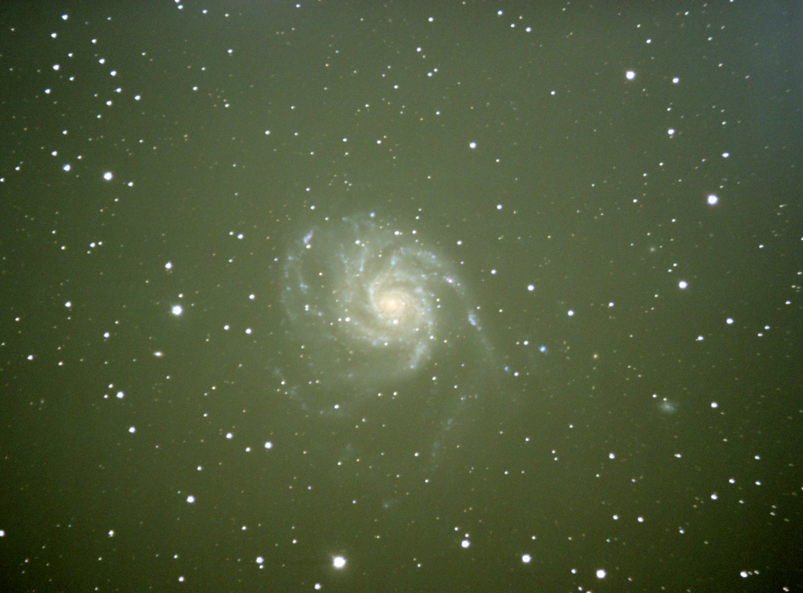Illustration 3: Messier 101, courtesy of Charles Kuehne
Wipe works by calculating a model of the unwanted light and then subtracting it from the image. The result is an image that is free from the unwanted light sources (below).
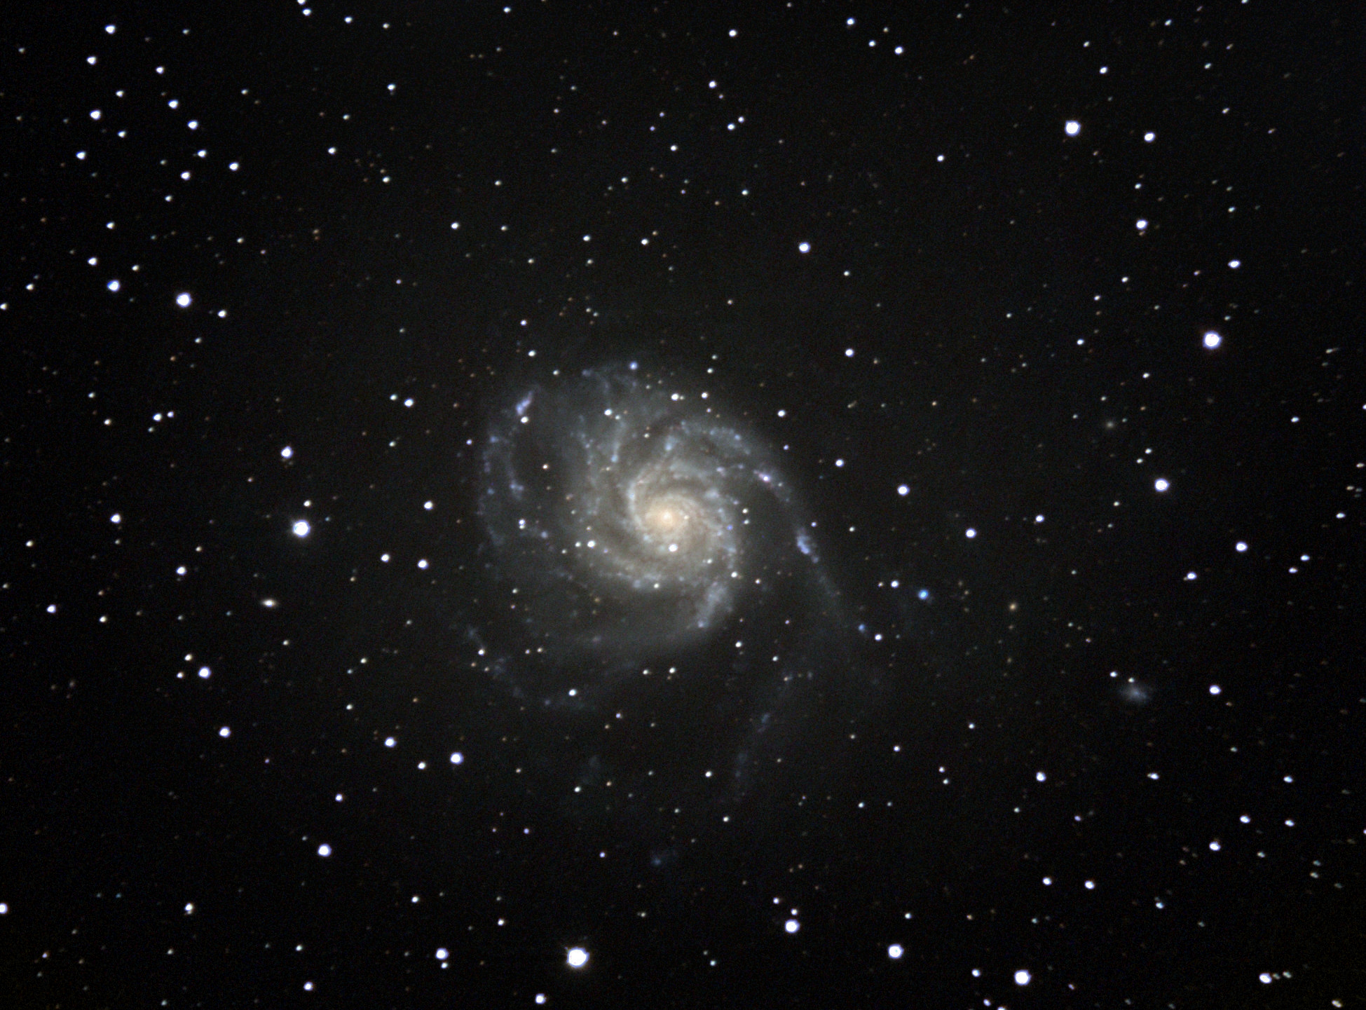Illustration 4: Messier 101, processed by StarTools Wipe
The Wipe module has 9 adjustable parameters and settings;
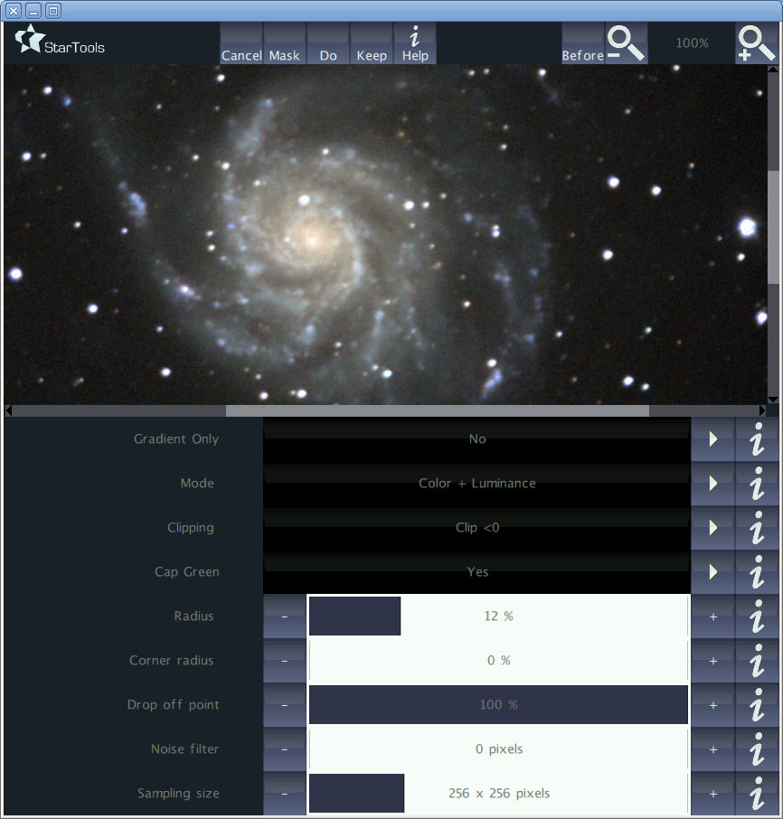Illustration 5: Wipe module interface
- Gradient Only; specifies whether Wipe should only output the calculated model of the unwanted light.
- Mode; specifies whether Wipe may adjust colour, luminance (brightness) or both.
- Clipping; specifies what Wipe should do in the very worst case when Wipe needs to subtract light from a pixel that's got not enough light to subtract (e.g. resulting in a 'blacker than black' pixel).
- Cap green; specifies whether Wipe should filter out any green hues from the image, treating them as aberrations and noise. The reasoning is that very few, if any, objects in outer space emit green light.
- Radius; effectively specifies the strength or 'aggressiveness' of the light removal process. Lower values are more aggressive. Radius controls how sensitive Wipe should be to sudden local changes in the unwanted light.
- Corner Radius; effectively specifies the strength or 'aggressiveness' of the light removal process in the corners. Lower values are more aggressive. This setting is designed to allow Wipe to be more aggressive in the corners where vignetting may be a problem. Vignetting is often characterised by a relatively sudden drop in light levels in the corners. Therefore a more aggressive value for Corner Radius (e.g. a lower value for 'Corner Radius' than 'Radius') may be in order. Even a value of 0% may be appropriate.
- Drop off point; specifies how far from the centre of the image the radius should modulate to the 'Corner Radius' value (e.g. at which distance from the centre of the image will the 'Corner Radius' take effect of the 'Radius' value). This setting effectively tells Wipe at which distance from the centre to expect vignetting to occur towards the corners. Hence, keeping the 'Drop off point' value at the default 100% will tell Wipe not to expect any vignetting at all. In that case 'Corner Radius' will have no effect.
- Noise filter; specifies the kernel radius of a Gaussian filter that removes high frequency detail (such as noise and hot/dead pixels) from the image before passing it to the gradient modeller. Use this setting if your image contains visible noise or hot or dead pixels to keep Wipe from introducing artefacts such as those in the image below. A faint blueish/gray (lower right) and yellowish (centre) patch can be seen. The cause was a cluster of red and blue pixels respectively. Note that employing the noise filter may result in some minor clipping, which in that case will be dealt with in the manner specified by the 'Clipping' parameter (see above).
- Sampling size; specifies precision with which the gradient model is constructed. Consider lowering this if using higher 'Radius' values and computation takes too long.
While Wipe performs quite well on most images with minimal user intervention, sometimes it needs direction on which parts of the image contain unwanted light and which parts of the image do not constitute unwanted light (for example galaxies, nebulas, trees and other terrestrial scenery), etc.
For those cases it may be appropriate to create a Mask in the mask editor which specifies which pixels of the image Wipe should sample for unwanted light and which pixels of the image Wipe should ignore.
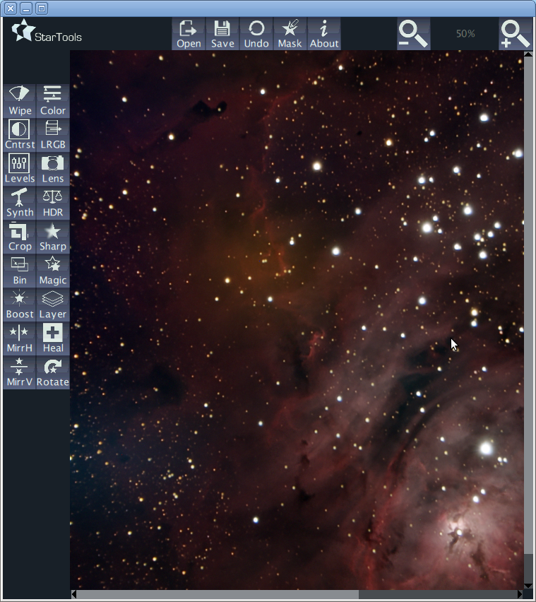Illustration 6: Two artefacts introduced by Wipe as result of the presence of 2 patches of hot pixels.

Color
The Color module allows for flexible manipulation of the image's colour, whether it be locally through the use of a mask or globally.
The Color module has 12 adjustable parameters and settings;
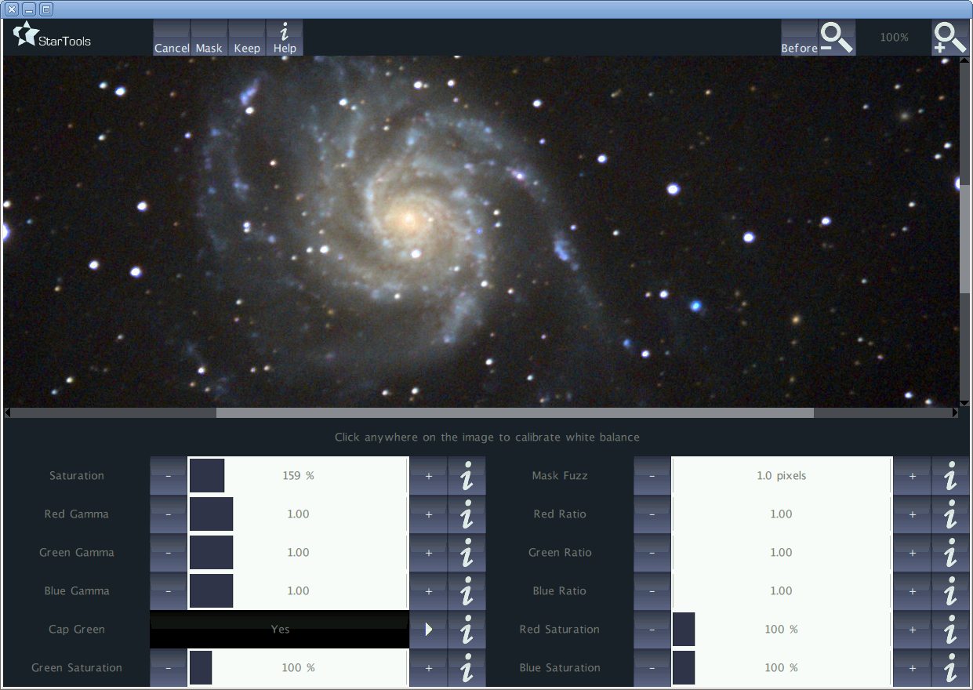Illustration 7: Color module interface
- Saturation; specifies the amount of colour saturation as a percentage of the original image. Increasing this value will make colours more vivid. Decreasing this value will make colours less vivid, to the point where the image becomes a grayscale image.
- MaskFuzz; specifies the kernel radius of a Gaussian blur to be (non-destructively) applied to the current mask. This allows selections to be affected smoothly, with no clear boundaries visible between processed and non-processed pixels.
- Red Gamma; adjusts the gamma value of the red channel.
- Green Gamma; adjusts the gamma value of the green channel.
- Blue Gamma; adjusts the gamma value of the blue channel.
- Red Ratio; adjusts a multiplier that should be applied to the red channel. Note that top-end clipping may occur as a result. Note also that this value is automatically adjusted by clicking on the image to adjust white balance.
- Green Ratio; adjusts a multiplier that should be applied to the green channel. Note that top-end clipping may occur as a result. Note also that this value is automatically adjusted by clicking on the image to adjust white balance.
- Blue Ratio; adjusts a multiplier that should be applied to the blue channel. Note that top-end clipping may occur as a result. Note also that this value is automatically adjusted by clicking on the image to adjust white balance.
- Red Saturation; performs a Gamma adjust to the red channel, but forces the image to retain its luminance.
- Cap green; specifies whether Color should block any green hues from forming in the image. The reasoning is that very few, if any, objects in outer space emit green light.

Contrast
The Contrast module performs local contrast enhancement. It optimises contrast in both bright and dark areas.
The Contrast module consists of two screens. On the first screen the parameters are set that are used to model a contrast map.
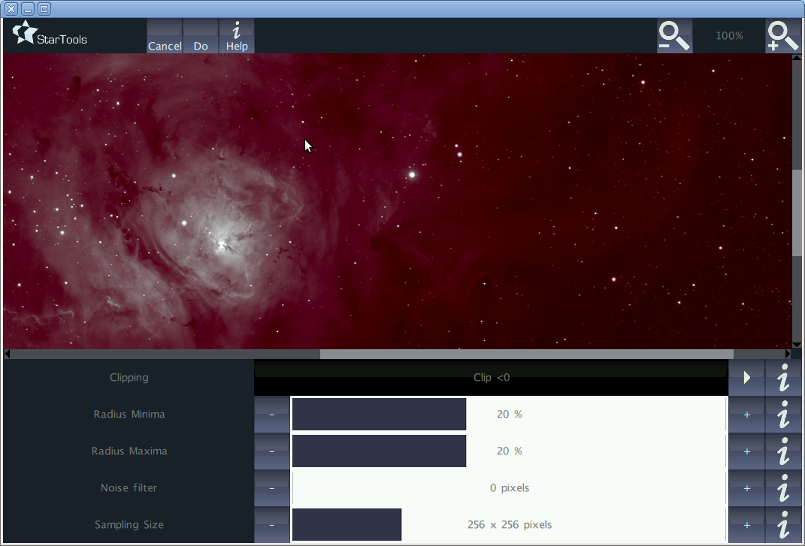Illustration 8: Contrast module 1st screen interface
On the second screen the strength of the contrast enhancement, as well as the way the contrast map is applied may be controlled.
The result on the latter screen is calculated in real-time, whereas the contrast map is not calculated real-time (a status bar is displayed) due to its potentially long and intensive calculations.
The Contrast module's 1st screen has 5 adjustable parameters and settings;
- Clipping; specifies what Contrast should do in the very worst case when Contrast needs to subtract light from a pixel that's got not enough light to subtract (e.g. resulting in a 'blacker than black' pixel).
- Radius Minima; effectively specifies the strength or 'aggressiveness' of the contrast enhancement process when dealing with areas that are (too) bright. Lower values are more aggressive at suppressing light areas.
- Radius Maxima; effectively specifies the strength or 'aggressiveness' of the contrast enhancement process when dealing with areas that are (too) dark. Lower values are more aggressive at lifting dark areas.
- Noise filter; specifies the kernel radius of a Gaussian filter that removes high frequency detail (such as noise and hot/dead pixels) from the image before passing it to the gradient modeller. Use this setting if your image contains visible noise or hot or dead pixels to keep Contrast from introducing artefacts. Note that employing the noise filter may result in some minor clipping, which in that case will be dealt with in the manner specified by the 'Clipping' parameter (see above).
- Sampling size; specifies precision with which the contrast map is constructed. Consider lowering this if using higher 'Radius' values and computation takes too long.

The Contrast module's 2nd screen has 2 adjustable parameters and settings;
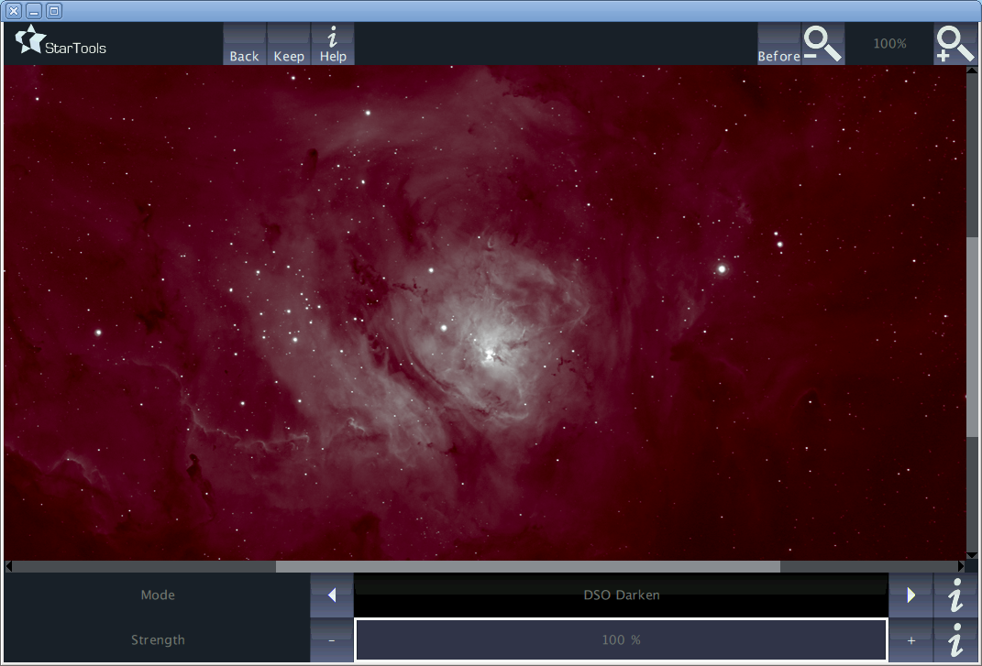Illustration 9: Contrast module 2nd screen interface
- Mode; specifies the way the Contrast map should be applied. 'DSO' applies both light and dark corrections. 'DSO Darken' applies only corrections that darken the image. 'DSO Lighten' applies only corrections that lighten the image. Finally, 'Planetary/Moon' is a slightly milder alternative to the 'DSO' mode, more suitable for Planetary and Moon targets.
- Strength; specifies the strength of the contrast correction where 0% specifies no correction and 100% specifies full correction.

LRGB
The LRGB module is a flexible colour image compositor. It allows you to mix and match Luminance, Red, Green and/or Blue images.
LRGB features automatic colour interpolation to make up for any missing channels. This feature is particularly useful when, for example, creating a composite from Ha and Hb data in the red and blue channels. LRGB will automatically generate the green channel in this instance.
LRGB also imports colour images and extracts channels as appropriate. For example, importing a colour image into the red channel, will automatically only extract the red data from the colour image.
Additionally LRGB features two types of chromatic (colour) noise reduction, as well as a convenient ratio adjust in order to synchronise exposure times between channels.
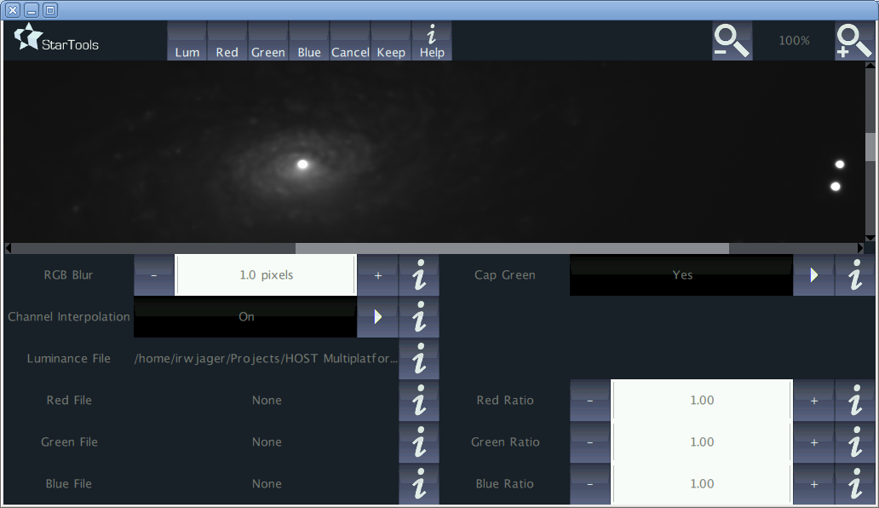Illustration 10: LRGB module interface
Please note that when importing files, all files must have the same dimensions. There is one exception where files that are exactly ½ the size of the luminance channel are acceptable for red, green or blue channels. This is so that the luminance channel may be recorded at 1x1 binning, while red, green and blue may be recorded at 2x2 binning.
The LRGB module has 10 adjustable parameters and settings;
RGB Blur; specifies the kernel radius of a Gaussian blur that is applied to the red, green and blue channel in case of importing an LRGB image. Note that this option only takes effect if a luminance channel is present. Often more imaging time is spent on acquiring the luminance frame, to which the human eye is much more sensitive. The red, green and blue data can often be of a much lower quality (and thus noisier) without seeing much difference. Blurring the red, green and blue data effectively acts as a low-pass filter, eliminating the noise in the red, green and blue channels. Even with heavy blurring of the red, green and blue channels in an LRGB composite, the difference is often hard to tell, however colour noise will be all but eradicated.
Channel interpolation; toggles on, or off the interpolation of missing channels. This feature is particularly useful when, for example, creating a composite from Ha and Hb data in the red and blue channels, without a green channel. LRGB will automatically generate the green channel in this instance. It will do the same for any other missing channel.
Cap green; specifies whether LRGB should block any green hues from forming in the image. The reasoning is that very few, if any, objects in outer space emit green light.
- Red Ratio; adjusts a multiplier that should be applied to the red channel. Note that top-end clipping may occur as a result. This value may be used to attain the exposure duration equivalent of the other channels. For example, if the red frame was a 30 minute exposure and the green and blue frames were both 45 minute exposures, then the red ratio should be set to 1.5 to make up for the red channels' shorter exposure duration.
- Green Ratio; adjusts a multiplier that should be applied to the green channel. Note that top-end clipping may occur as a result. This value may be used to attain the exposure duration equivalent of the other channels.
Blue Ratio; adjusts a multiplier that should be applied to the blue channel. Note that top-end clipping may occur as a result. This value may be used to attain the exposure duration equivalent of the other channels.
Luminance File; shows the path of the file that is used as the luminance channel. Note that if this file is a colour file, then a grayscale conversion of this file is used.
Red File; shows the path of the file that is used as the red channel. Note that if this file is a colour file, then the red channel is extracted from this file.
Green File; shows the path of the file that is used as the green channel. Note that if this file is a colour file, then the green channel is extracted from this file.
Blue File; shows the path of the file that is used as the blue channel. Note that if this file is a colour file, then the blue channel is extracted from this file.

Levels
The Levels module is typically one of the first modules to be used on raw stacked data. Astronomical images are a bit different for terrestrial images in that most things in the image are extremely bright (stars) or extremely faint (nebulas, galaxies, etc.), with little in between. The Levels module is the first port of call to fix this.
It was designed to do two things;
- 'Developing' the raw linear CCD data into human-eye-friendly non linear data.
- Adjusting levels during post processing.
The Levels module is equipped with various ways to reduce noise. The philosophy is that noise (especially 'read noise') is best dealt with early on while it is still linear. Once noise gets stretched along with the real signal it starts to become harder to control and various algorithms may yield less optimal results because of its presence.
Please note that, when developing a freshly stacked raw image, be sure to crop any stacking artefacts from the image. It is also advisable to remove any dead pixels (see the Masks and Heal chapters) before proceeding.
The Levels module automatically normalises the image levels to maximise headroom for processing. It is recommended to keep the levels normalised (maximising the available headroom) until finalising the image, as various algorithms in StarTools work best with normalised data. When finalising the image, a base level (commonly associated with natural phenomenon such as sky glow, gegenschein, etc.) may be added to the image. Note that the normalising algorithm may be confused by any non-natural artefacts such as stacking artefacts and dead pixels.
The Levels module has 9 adjustable parameters and settings;
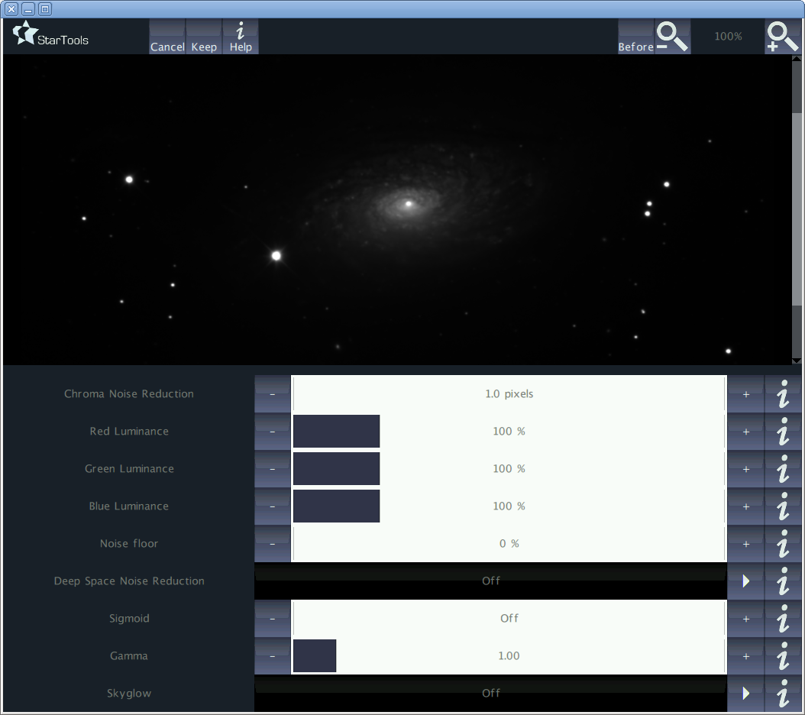Illustration 11: Levels module interface
Chroma Noise Reduction; specifies the kernel radius of a Gaussian blur that is applied to the chrominance (colour) components of the image, leaving the luminance (brightness) intact. Often more imaging time is spent on acquiring the luminance frame, to which the human eye is much more sensitive. The red, green and blue data can often be of a much lower quality (and thus noisier) without seeing much difference. Blurring the red, green and blue data effectively acts as a low-pass filter, eliminating the noise in the red, green and blue channels. Even with heavy blurring of the red, green and blue channels, the difference is often hard to tell, however colour noise will be greatly reduced.
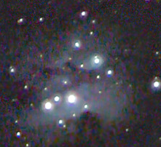Illustration 12: Running Man Nebula with severe chromatic noise
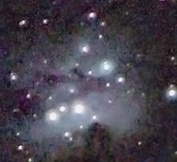Illustration 13: Running Man Nebula with Chroma Noise Reduction applied.
Red Luminance; specifies the red channel's contribution to overall luminance. Lowering this value may be beneficial when the luminance data from the red channel is of poor quality. For example when imaging with a OSC or webcam without an infrared filter.
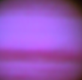Illustration 14: Raw Jupiter detail with all channels contributing to luminance equally.
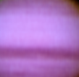Illustration 15: Raw Jupiter detail with only the green channel contributing to luminance.
Green Luminance; specifies the green channel's contribution to overall luminance. Lowering this value may be beneficial when the luminance data from the green channel is of poor quality.
Blue Luminance; specifies the green channel's contribution to overall luminance. Lowering this value may be beneficial when the luminance data from the blue channel is of poor quality. For example, when imaging with an OSC or webcam without a UV filter.
Noise Floor; specifies the brightness level below which the 'Deep Space' noise reduction kicks in.
Deep Space Noise Reduction; switches between different modes of 'Deep Space Noise Reduction'. Deep Space Noise Reduction applies the chosen noise filter type to pixels that are darker than the Noise Floor (see above). Possible modes are;
Off; no noise reduction is performed.
Desaturate; progressively fades pixels to black & white. This mode is very effective for reducing color noise in the darker areas.
Filter; applies a Gaussian Blur (low-pass) filter to the darker areas, getting rid of fine noise.
Desaturate + Filter; combines the benefits of both Desaturate and Filter modes.
Sigmoid; specifies the amount of non-linearity in the gamma adjusted (see below) signal. Closely related to the DDP (Digital Development Processing) algorithm, this parameter allows for quick 'Digital Development' of a raw stacked image. It effectively allots more headroom to the the very darkest and lightest parts of the image, bringing out faint details and taming the very brightest. This behaviour is also very similar to photographic film response to low and bright light.
Gamma adjust allows for adjusting the image to the non linear response of media like your monitor, printer, etc. (which typically needs a gamma correction of 2.2).
Skyglow; specifies the amount of skyglow to be added to the image. Skyglow is effectively a minimum base level that all pixels will get. Possible modes are;
Off; no skyglow is added.
10% Add Headroom; adds a base level of 10% of the maximum brightness to the image. The image's brightness is effectively squeezed into the remaining 90%. No bottom-end or top-end clipping occurs.
10% Clip; sets any pixels that have a brightness of 10% or less to 10%. This means that any pixel information that was darker than 10% will be lost.
5% Add Headroom; adds a base level of 5% of the maximum brightness to the image. The image's brightness is effectively squeezed into the remaining 95%. No bottom-end or top-end clipping occurs.
5% Clip; sets any pixels that have a brightness of 5% or less to 5%. This means that any pixel information that was darker than 5% will be lost.

Lens
The Lens module allows for correcting common lens- and mirror aberrations and defects, such as chromatic aberration and coma.
The Lens module has 9 adjustable parameters and settings;
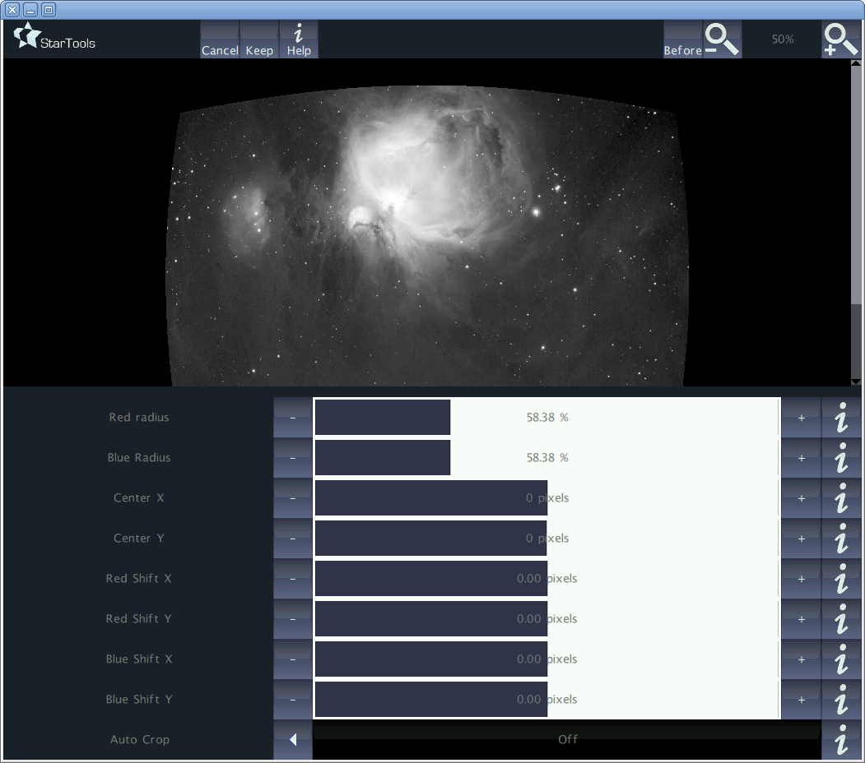Illustration 16: Lens module interface
Red radius; specifies the curvature strength of the red channel.
Blue radius; specifies the curvature strength of the blue channel.
Center X; specifies the central X coordinate of the distortion.
Center Y; specifies the central Y coordinate of the distortion.
Red shift X; specifies the amount of (fractional) pixels to shift the red channel's pixels in the horizontal direction.
Red shift Y; specifies the amount of (fractional) pixels to shift the red channel's pixels in the vertical direction.
Blue shift X; specifies the amount of (fractional) pixels to shift the blue channel's pixels in the horizontal direction.
Blue shift Y; specifies the amount of (fractional) pixels to shift the blue channel's pixels in the vertical direction.
Auto crop; toggles the auto cropping feature on or off. Because a distorted image may curve/bulge when it is corrected, not all pixels in the final image may be populated. Auto cropping will crop the image in such a way that all pixels are populated. This will mean, however, that some pixels at the edges may be lost as a result.
To correct coma, simply adjust the Red Radius and Blue Radius by the same amount until stars no longer appear elongated.

Masks

Tutorials

Acknowledgements

